The Whitehouse
An Invitation to Innovate

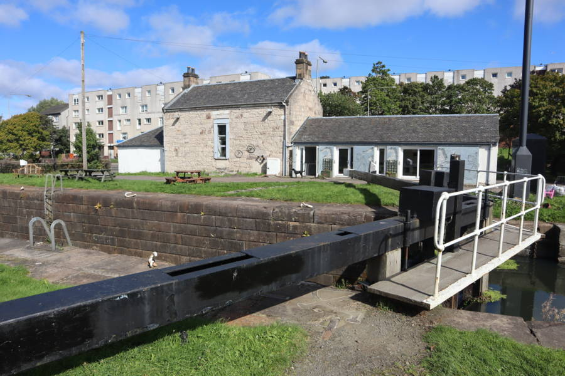

Free Wheel North is offering access to an atmospheric venue in Maryhilll Glasgow for cafe, catering, or hospitality partnerships.
Whether you're launching a new concept, testing a second location, or hosting premium events, this is a rare opportunity to trade in a heritage building in an unrivalled location—without the overhead of full-time premises.
Location
🌊 The Whitehouse, Maryhill – Historic canalside building with heritage charm
Your Opportunity:
✔️ Day time and Evening venue hire, flexible days)
✔️ Use existing café/kitchen facilities (details below), some investment needed.
✔️ Fixed hire fee or partnership model
✔️ Support a local charity with national recognition

🌊 The Whitehouse, Maryhill
- Canalside heritage venue with striking views of the Forth & Clyde Canal
- Intimate, characterful space with event potential
- Potential daytime use for café and training – open for evening development
- Requires minor fit-out for restaurant-grade use
Ideal for:
- Seasonal pop-ups
- Cultural or community-themed food nights
- Private dining or high-end supper clubs

